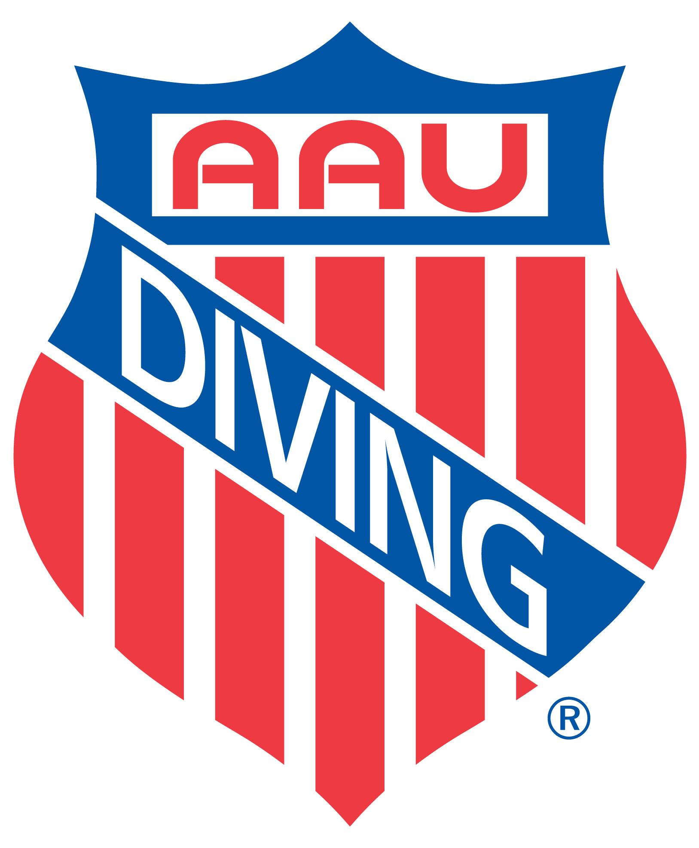
2021 AAU Diving
National Championships
July 18-25, 2021
Morgantown, West Virginia

Meet Location: Mylan Park Aquatic Center
500 Mylan Park Lane
Morgantown, WV 26501 Mylan P

Meet Directors: Joelle Cabassol and Kathy Davis
JoelleandKathyAAUDiving@gmail.com

Qualifying Standards: Due to COVID and lack of competitions for many divers, qualifying scores have been waived for this year’s meet. We ask that coaches use their discretion when bringing divers to this meet. It will be a national-level competition and may not be suited for all divers.

ISF Qualification Meet: On July 25, the top 5 finishers in the girl’s and boy’s 16, 17 and 18 age groups are invited to compete for two spots per event to on Team AAU representing the United States at the International School Sport Federation Gymnasiade in Jinjiang, China on October 16-23, 2021. Team AAU representing the United States will consist of 10 boys & 10 girls selected from the qualification meet. More information on selection is available here ISF Meet Information.

Daily Events Schedule: Refer to the daily event schedule for the days you will be competing. Specific start times will be posted on July 11, 2021 and are based on the number of entries on any given day. Events may be combined and split to allow for a more efficient timeline. Prelims in the morning and finals (top 12) in the evening are held for all events except tower and synchro events. AAU recommends you make your return-home travel plans for the day after your diver’s last event.

AAU Membership: All athletes and coaches must have a 2021 AAU Membership before registering online; for athletes the fee is $14 and for coaches the fee is $16. For more information on AAU Membership, or to purchase your athlete or non-athlete membership go to www.aausports.org.

You may no longer register for non-athlete (coach) membership onsite. Background screens are conducted at no cost for all non-athletes and adult athletes. Membership is no longer instant. BE PREPARED and register your coaches early! For more information, visit www.aausports.org.

Entry Process: Register on CleanEntries.com.

After a registration is submitted, CleanEntries will verify the diver’s current AAU membership. The CleanEntries profile for the diver must match exactly the diver’s AAU profile by name, birth date, and zip code. If they do not match exactly, the registration will not be allowed and the user will receive a message indicating a problem with the AAU membership.

All coaches (head & assistants) must register their intended attendance at the meet online on CleanEntries.com. All coaches and athletes must be currently registered with AAU to be allowed access to the deck.

Ontime Entry Fee: $60.00 per individual event (Entry fees are NON-REFUNDABLE)
See Daily Events Schedule for details

Ontime Entry Deadline: Ontime Entry Deadline July 6, 2021 5:00 PM EST
AAU offers the option to pay timely entry fees after divers have finished registering for all their events. ALL UNPAID ENTRIES REMAINING AFTER 5:00 PM (EST) ON JULY 6, 2021 WILL INCUR THE $50.00 LATE FEE.

Note: Any entries received after July 6, 2021, 5:00 PM (EST) may not appear on any event printed materials (such as the t-shirt, credentials, etc.).

Late Entries/Fees: ******NEW!******NEW!***** NEW!*****NEW!*****NEW!****** LATE ENTRIES WILL OPEN ON JULY 6, 2021 AT 5:01 PM (EST) AND WILL BE ACCEPTED ONLINE THROUGHOUT THE MEET UNTIL 8:00 PM (EST) THE NIGHT BEFORE THE SCHEDULED EVENT with the exception of Synchro entries. The one-time late fee of $50 per diver will be added to the individual entry fees. NO DECK-PAPER ENTRIES WILL BE ACCEPTED, other than for synchro entries. (Entry fees are NON-REFUNDABLE)

Online Synchro Entry: $60.00 per team/event (Entry fees are NON-REFUNDABLE)
Online Synchro entries will close at 5:00 pm (EST) July 6, 2021.
ALL SYNCHRO ENTRIES MADE AFTER July 6, 2021 AT 5:00 PM (EST) MUST BE MADE ON PAPER AT THE REGISTRATION TABLE.

Deck Synchro Entry Fee: $60.00 per team/event (Entry fees are NON-REFUNDABLE)
No Late Fee for Synchro if entries are received by 8:00 pm the night before the
scheduled event.
Synchro Late Fee: $50.00 late fee per team will be added to the synchro entry fees received 8:01 PM the night before to 10:00 AM the day of competition.
No same-day Synchro Entries accepted after 10:00 AM (EST) the day of competition.

International Divers: AAU welcomes international divers to compete in the meet. International divers will compete in their appropriate age group along with American divers. They will not displace American divers in the standings. They will be awarded medals based on their standings within the International Divers only. Coaches, please advise the Meet Directors if you have international divers competing on your team.

Dive Changes: Dive changes must be made online including late entries at CleanEntries.com, except for Deck-Entered Synchro sheets and Finals (following preliminaries) events.
Divers may make dive changes using their phones/internet devices.
Go to CleanEntries. Click on 2021 AAU Nationals, (no need to sign-in). Click on the Blue Online Changes button. Follow prompt

Dive Change Deadlines: For Preliminary and Tower events:
- Events in first session of each day: 8:00 PM the night before
- Events in session 2 and over: 2 hours prior to the posted start time
No late changes will be accepted (including position changes) No fees for dive changes.
For Finals: 30 minutes following the completion of the preliminary session.
For Synchro: 10:00 AM the day of the event.

Competition Format: AAU uses “single-age” age groups.
Ages are determined by age on December 31, 2021.
FINA rules except where modified for this meet.
All prelims will be in the morning sessions.
Top 12 in each event will compete in the evening finals.
Each event is assigned a day which will not change.
The order of events/timeline will be published on July 11, 2021.
Divers are assigned boards.
We use a split-board system on larger events cutting the event time by half.

Board Assignments: Divers’ Board Assignments will be emailed to coaches and posted Diveaau.org on July 11, 2021

Timeline: The meet Timeline will be emailed and posted on July 11, 2021

Awards: Medals and AAU All-American Certificates will be awarded to the top 12 finishers in individual events. The top six teams in synchronized events will receive medals. Every athlete will be awarded an AAU National Championship Certificate. Each registered participant will receive a free AAU T-shirt and “more”.

Warm ups: Open warm-ups in the morning.
Event specific warm-ups will be held before each event.
The pool will be available for open warm-ups each day between the morning session and the final sessions.

Admission & Parking: Spectator admission & Parking are required for all events.
Admissions Per Day: $10.00 (Ages 5 & Up)
Parking/Person/Day $2.00 (Ages 5 & Up)
No Parking fee for Divers and coaches with Credentials

Admission Entire Meet: $30.00 (Ages 5 & Up)
Parking with Week Pass $5.00 (Ages 5 & Up)
(Per person/day)
No Parking fee for Divers and coaches with Credentials

Housing: The Morgantown Convention Bureau has secured discount prices at a variety of area hotels, or visit Diveaau.org

Paid Volunteers: AAU will be requesting volunteers to assist with the meet and will send an online form with available positions. AAU will pay the club of the volunteer for their work at a rate of $10/prelim and tower sessions and $5/final and synchro sessions. Link to a sign-up form will be emailed to coaches and the email addresses associated with registrations on CleanEntries.

Celebration of Athletes: More details coming soon

Coaches Education: The AAU National Office is happy to announce to its members, free Coaches' Education for all AAU Non-Athletes. This exciting program is mandatory for all AAU Non-Athletes and will be administered by Positive Coaching Alliance (PCA). Please visit www.aausports.org and click on JOIN NOW in order to enter and take the mandatory AAU/PCA coaches educational course. Membership may be revoked from non-athletes who do not complete the course prior to competition.

Coaches Meetings: July 17 and July 20, 2021 - 7:30 PM at the pool.

BBQ Festival: The City has organized a BBQ Festival July, 16 - July 18 with outdoor activities Games, and lots of BBQ! over 30 different wings! Location is right next to the pool.

Coaches Seminar: TBD

Judges: An online judges sign-up form will be emailed to coaches July 8th, 2021. The sign-up form will close on July 10. Judges Panels for preliminary and tower events will be created with preference towards the sign-ups. Coaches from all teams attending the meet will be assigned judging slots. TheJudging Panels will be emailed to coaches before the 14th.

AAU Contact: Tony Staley
AAU National Headquarters
407-934-7200(O)
407-934-7242 (F)
tony@aausports.org

Age Division:

- 9 and Under Boys and Girls (Group E)  - 10 to 11 Boys and Girls (Group D)  - 12 to 13 Boys and Girls (Group C)  - 14 to 15 Boys and Girls (Group B)  - 16 to 18 Boys and Girls (Group A)  - 19+ Boys and Girls (Group A+) | - This is a single age group championship.  - Age is determined by December 31, 2021  - All age group divers remain qualified from the 1st of January to midnight of the following 31st December in the year of competition.  - Springboards will be Individual age groups  - Tower events will be FINA age groups.

Dive Requirements:

Group E, 9 & Under | Group D, 10 & 11 years old | Group C, 12 & 13 years old
Boys and Girls  3 vols, 1 opt  vols max 1m 5.4, 3m 5.4 | Boys and Girls  5m only  3 vols, 2 opts  vols max 1m 5.4, 3m 5.4  Tower 11 & Under (5 m only)  Total DD ≤ 5.4  3 vols, 2 opts | Girls 5 vols, 2 opts  Boys 5 vols, 3 opts  Vols Max 1m 9.0, 3m 9.5  Tower: 5m & 7m only; total DD ≤7.6  Boys: 4 vols, 3 opts Girls: 4 vols, 2 opts  Synchro: 13 & Under  Boys & Girls 1m & 3m – 4 dives  2 vols-dif. groups, vols=2.0 DD  2 opts-dif. groups, Opts=true DD
Group B, 14 & 15 years old | Group A, 16, 17 & 18 years old | Group A+, 19+
Girls 5 vols, 3 opts  Boys 5 Vols, 4 opts.  vols Max 1m 9.0, 3m 9.5  Tower: 5m-7m-10m, Total DD ≤7.6  Boys: 4 vols, 4 opts Girls: 4 vols, 3 opts  5 groups total  Synchro: 14-15  Boys & Girls 1m & 3m – 5 dives  2 vols-dif. groups, vols=2.0 DD  3 opts-dif. groups, Opts=true DD | Girls 5 vols, 4 opts  Boys 5 vols, 5 opts  vols Max 1m 9 0, 3m 9.5  Tower: 5m-7m-10m, Total DD ≤7.6  Boys: 4 vols, 5 opts Girls: 4 vols, 4 opts  6 groups total  Synchro: 16-19+  Boys & Girls 1m & 3m – 5 dives  2 vols-dif. groups, vols=2.0 DD  3 opts-dif. groups, Opts=true DD | Girls 6 opts, 5 groups  Boys 6 opts, 5 groups  No DD limit  Tower: 5m-7m-10m, no DD Limit  Boys: 6 opts Girls: 5 opts  5 groups total

2021 AAU DIVING NATIONAL MEET SCHEDULE

Friday, July 16, 2021
- Warm up/practice: 10:30 am - 7:30 pm
- Athlete Check-in: starting at 10:30 am

Saturday, July 17, 2021
- Pool Open Dryland: 6:30am
- Water warm-up: 7:00 am - 7:15 pm
- Coaches meeting 7:30 PM @ hospitality room

Open warm-ups each morning and afternoon between morning sessions and final events. If time permits, more open warm-ups will take place between prelims and finals. Event warm-ups will take place before each event.

Day 1 - Sunday, July 18, 2021

Girls |  | Boys
Age Group | Event | Age Group | Event
9 & Under (Group E) | 3 Meter | 9 & Under (Group D) | 1 Meter
10 (Group D) | 1 Meter | 10 (Group D) | 1 Meter
11 (Group D) | 3 Meter | 11 (Group D) | 3 Meter
12 (Group C) | 3 Meter | 12 (Group C) | 1 Meter
13 (Group C) | 3 Meter | 13 (Group C) | 1 Meter
13 & Under | 1 Meter Synchro | 13 & Under | 3 Meter Synchro

Day 2 - Monday, July 19, 2021
Girls |  | Boys
Age Group | Event | Age Group | Event
9 & Under (Group E) | 1 Meter | 9 & Under (Group D) | 3 Meter
10 (Group D) | 3 Meter | 10 (Group D) | 3 Meter
11 (Group D) | 1 Meter | 11 (Group D) | 1 Meter
12 (Group C) | 1 Meter | 12 (Group C) | 3 Meter
13 (Group C) | 1 Meter | 13 (Group C) | 3 Meter
13 & Under | 3 Meter Synchro | 13 & Under | 1 Meter Synchro

Tuesday, July 20, 2021
Girls |  | Boys
Age Group | Event | Age Group | Event
11 & Under (Group D) | Platform | 11 & Under (Group D) | Platform
12-13 (Group C) | Platform | 12-13 (Group C) | Platform
14-15 (Group B) | Platform | 14-15 (Group B) | Platform

After diving events end:
- Celebration of Athletes
- Coaches Forum and Meeting

Wednesday, July 21, 2021
Girls |  | Boys
Age Group | Event | Age Group | Event
14 (Group B) | 3 Meter | 14 (Group B) | 3 Meter
15 (Group B) | 1 Meter | 15 (Group B) | 1 Meter
14-15 (Group B) | 1 Meter Synchro | 16 (Group A) | 3 Meter
 |  | 17 (Group A) | 1 Meter
 |  | 18 (Group A) | 1 Meter
 |  | 19+ (Group A+) | 1 Meter
 |  | 14-15 (Group B) | 3 Meter Synchro
 |  | 16+ | 3 Meter Synchro

Thursday, July 22, 2021
Girls |  | Boys
Age Group | Event | Age Group | Event
14 (Group B) | 1 Meter | 14 (Group B) | 1 Meter
15 (Group B) | 3 Meter | 15 (Group B) | 3 Meter
16 (Group A) | 1 Meter | 14-15 (Group B) | 1 Meter Synchro
17 (Group A) | 3 Meter
18 (Group A) | 1 Meter
19+ (Group A+) | 1 Meter
14-15 (Group B) | 3 Meter Synchro
16+ | 1 Meter Synchro

Friday, July 23, 2021
Girls |  | Boys
Age Group | Event | Age Group | Event
16 (Group A) | 3 Meter | 16 (Group A) | 1 Meter
17 (Group A) | 1 Meter | 17 (Group A) | 3 Meter
18 (Group A) | 3 Meter | 18 (Group A) | 3 Meter
19+ (Group A+) | 3 Meter | 19+ (Group A+) | 3 Meter
16+ | 3 Meter Synchro | 16+ | 1 Meter Synchro

Saturday, July 24, 2019
Girls |  | Boys
Age Group | Event | Age Group | Event
16-18 (Group A) | Platform | 16-18 (Group A) | Platform
19+ (Group A+) | Platform | 19+ (Group A+) | Platform

Note: The timeline will be set after entries are closed, and will be announced on . All divers will compete a full list in a morning preliminary session. Top 12 divers will compete an optional list in the evening finals session. Group E divers will perform all 4 dives in finals

2021 Scores to AAU Nationals
Qualification: Qualifications for the 2021 AAU Summer Nationals have been waived due to the Covid-19 situation. No special requirements needed. Although there are no minimum qualifications to enter this meet, coaches should exercise discretion inviting divers to compete. Skills are not national level dives. All divers must be registered with AAU.

Group E | 1 Meter | 3 Meter | Platform
9 & Under Girls | No minimum score (coaches please use discretion)
9 & Under Boys | No minimum score (coaches please use discretion)
Group D | 1 Meter | 3 Meter | Platform
10-11 Girls | 130 (5 Dives) | 140 (5 Dives) | 130 (5 Dives)
 | 150 (6 Dives) | 160 (6 Dives)
10-11 Boys | 120 (5 Dives) | 125 (5 Dives) | 130 (5 Dives)
 | 140 (6 Dives) | 150 (6 Dives)
Group C | 1 Meter | 3 Meter | Platform
12-13 Girls | 205 (7 Dives) | 210 (7 Dives) | 160 (6 Dives)
 | 225 (8 Dives) | 235 (8 Dives)
12-13 Boys | 185 (7 Dives) | 195 (7 Dives) | 190 (7 Dives)
 | 210 (8 Dives) | 225 (8 Dives)
Group B | 1 Meter | 3 Meter | Platform
14-15 Girls | 250 (8 Dives) | 260 (8 Dives) | 248 (7 Dives)
 | 284 (9 Dives) | 294 (9 Dives)
 | 362 (11 Dives)
14-15 Boys | 250 (9 Dives) | 270 (9 Dives) | 280 (8 Dives)
 | 382 (11 Dives)
Group A | 1 Meter | 3 Meter | Platform
16-18 Girls | 305 (9 Dives) | 315 (9 Dives) | 245 (8 Dives)
 | 340 (10 Dives) | 350 (10 Dives) | 275 (9 Dives)
 | 372 (11 Dives)
16-18 Boys | 365 (10 Dives) | 390 (10 Dives) | 305 (9 Dives)
 | 405 (11 Dives) | 430 (11 Dives) | 335 (10 Dives)
Open Group | 1 Meter | 3 Meter | Platform
19 & Over Girls | No minimum score (coaches please use discretion)
19 & Over Boys | No minimum score (coaches please use discretion)

Coaches: Please note that there is no qualifying standard for the 9 & unders. They will be doing 4 dives – 3 voluntaries and 1 optional on 1 and 3 meter. Please use your discretion by bringing divers who you feel are capable of competing at this meet. There is no 9 & under platform event, but 9 & unders may compete in the 11 & under platform.
Age groups are determined by the divers’ age on December 31, 2021. All divers must compete in their age group and qualify in that age group.
Preliminaries may be run as combined events. Example, Group D may be run for 10s and 11s together and then a final for the top twelve 10 year olds and a final for the top 11 year olds may be held.
Tower events will be run as finals only.

Mylan Park - Morgantown, WV - Pool Schematics
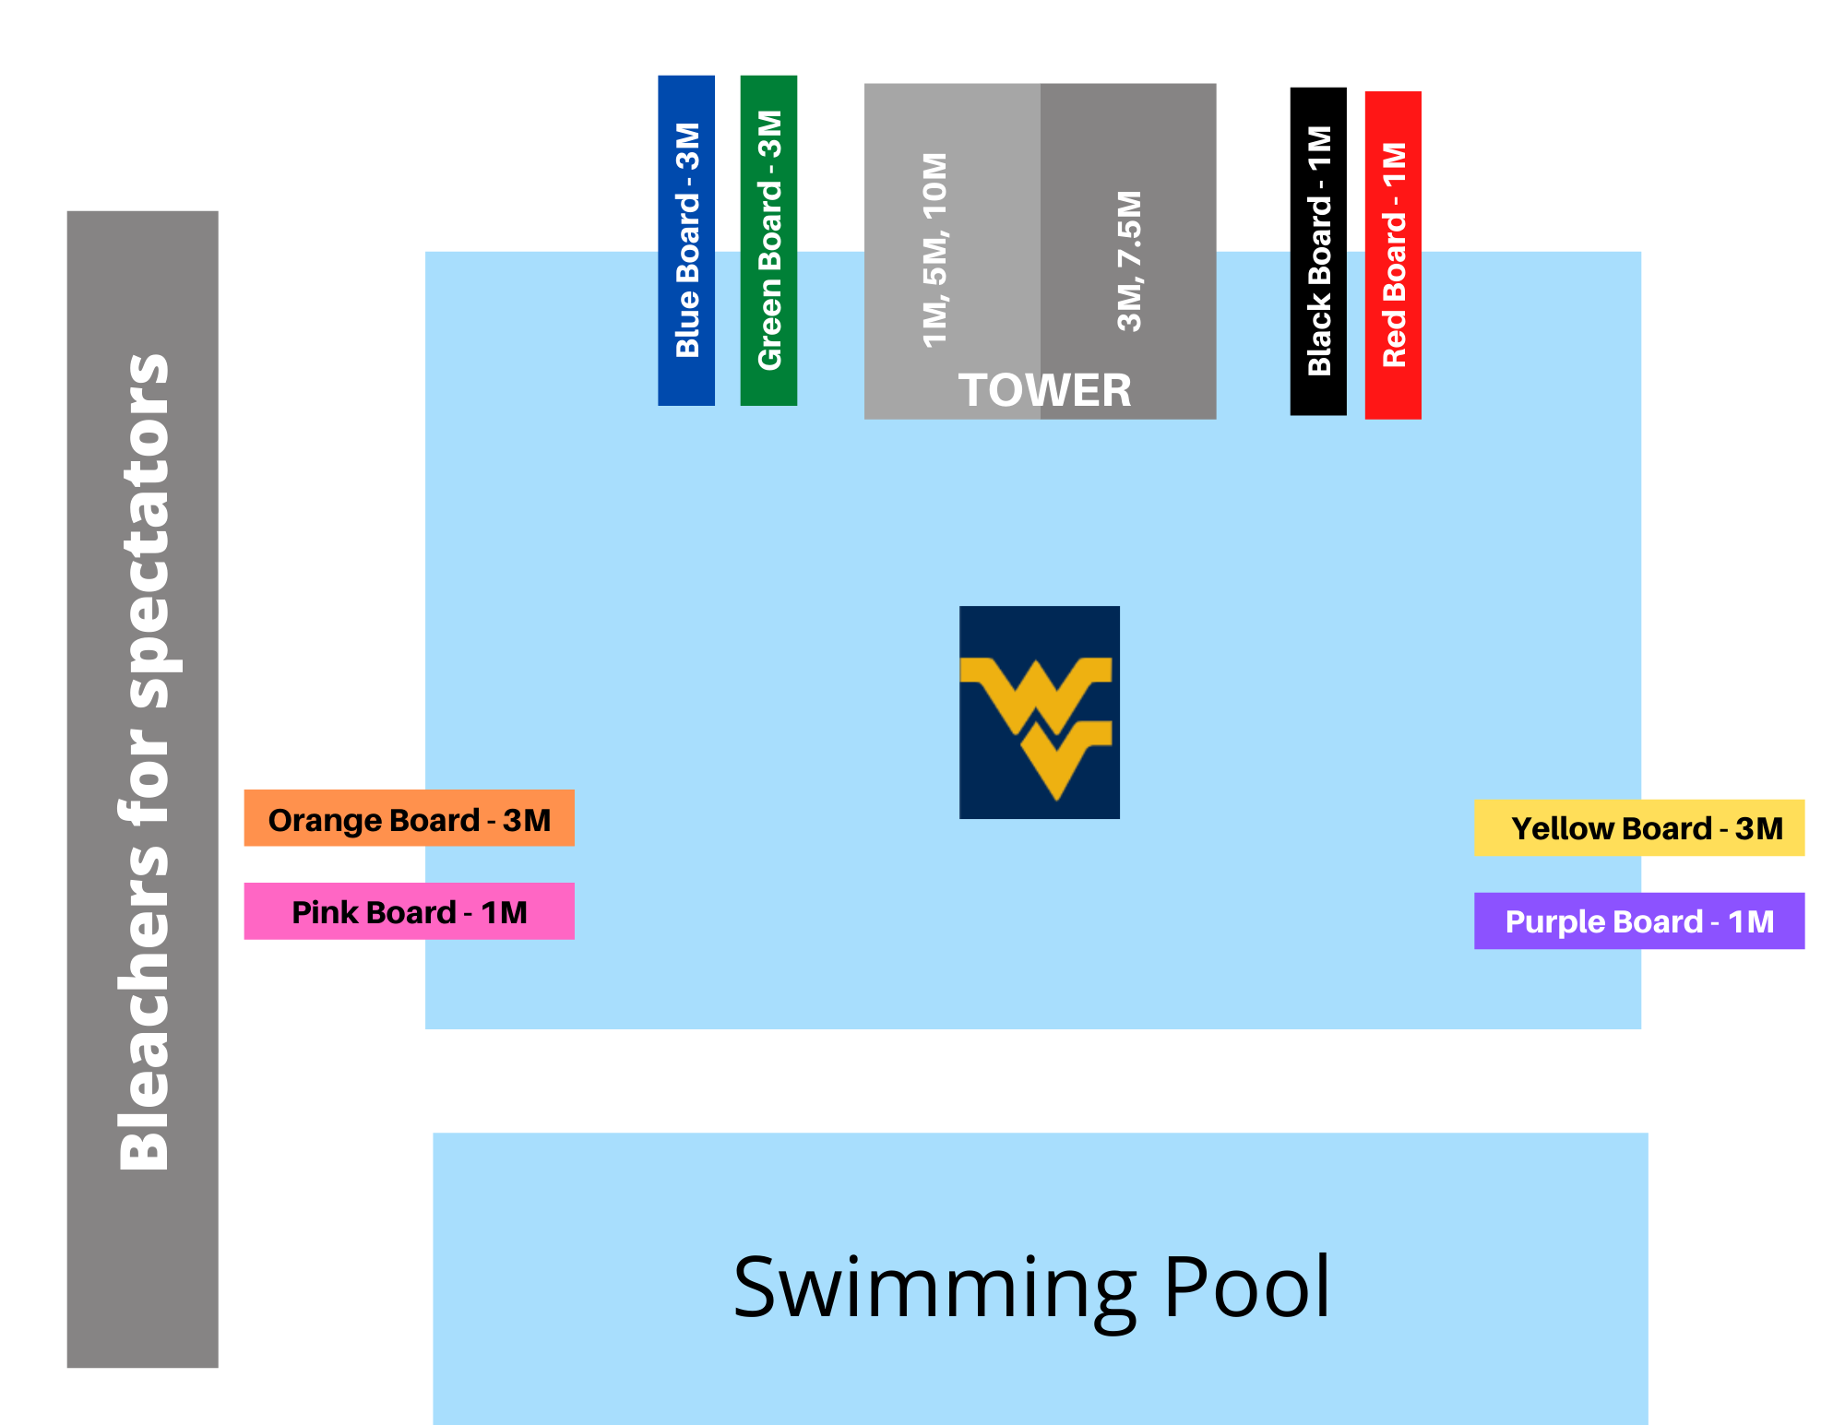

What Makes AAU Nationals Different?
- Divers do not have to travel to multiple qualifying meets to get to AAU Nationals, saving families time and money.

- The meet is structured in a logical way, making it economical and efficient. All divers 13 years old and younger dive during the first 3 days, with tower on day 3. Divers ages 14 & 15 dive on days 3-5, with tower on day 1. Divers age 16-19+ dive on days 4-7 with tower on day 7. There is ample warm-up time for all divers.

- In order to run the best meet possible, we make logical changes to the order of events in order to maximize efficiency. Final order of events/timeline will be published on July 11, 2021.

- Divers compete in single-age age groups (except tower and synchronized). For example, 16 years olds (FINA age) only compete against other 16 year olds (FINA age), putting divers on a more level playing field. Age groups are determined by the divers’ age on December 31, 2021. All divers must compete in their age group; divers may not dive up.

- AAU makes every effort to run a meet that provides a healthy atmosphere for divers and coaches. We welcome ideas and suggestions to improve the meet. We remain open to making changes that benefit divers and coaches. Diving coaches run AAU Diving, and our goal is to make diving accessible to more young and old athletes.

Is there anything else I need to know about qualifying?
Qualifications for the 2021 AAU Diving National Championship have been waived due to the Covid-19 situation. No special requirements needed. Although there are no minimum qualifications to enter this meet, coaches should exercise discretion in inviting divers to compete. All divers must be 2021 AAU Members

How do 9 & under divers qualify?
There is no qualifying standard for 9 & u divers. Coaches should use discretion and only bring divers who are capable of competing at this meet. There is no 9 & u platform event, 9 & u may compete in the 11 & u platform.

What else do I need to know about meet logistics?
When events are very large, we use a split-board system that reduces the time required by 50%.
In order to run the most efficient meet possible meet, we will not announce the final order of events until July 11, 2021. This allows us to line up events that match in size, minimizing down-time between the events. Many divers will be assigned a board. This approach allows us to provide ample open warm-up time in the afternoons.

There will be a march-in prior to the start of each final. Awards are held promptly after finals with the top 12
divers receiving medals. All finals divers should be prepared to be on the podium in their team uniform at end
of the event.

What is different about tower events?
Tower events will be run as finals only. Divers who compete in the meet may compete in the tower event. Coaches, please use your discretion before entering divers in tower. Tower competitors should not be learning new dives in warm-ups.

